

**KENYATTA UNIVERSITY**

**SCHOOL OF PURE AND APPLIED SCIENCES**

**DEPARTMENT OF COMPUTING AND LIBRARY SCIENCES**

**SIT 400: PROJECT**

**WIKONNECT COLLABORATIVE TEAM MANAGEMENT SYSTEM FOR STUDENTS**

**BRENDAH NYANCHAMA ONSOMBI**

**J31/3605/2021**

**SUPERVISOR: Mr. BENSON OKEBE**

*This proposal is submitted for the purpose of the requirements for the ward of the degree of Bachelor in Information Technology in the School of Pure and Applied Sciences of*

*Kenyatta University*

**OCTOBER 2024**

Figure 6: Flow chart for the current system 1

Figure 7: Use case diagram for the current system 2

Figure 8: ERD for the current system 3

Figure 9: Level 0 context diagram for the current system 3

Figure 10: Flow chart for the proposed system 7

Figure 11: Use case for the proposed system 8

Figure 12: Level 0 Context diagram for the proposed system 8

Figure 13: Level 1 context diagram for the proposed system 9

Contents

CHAPTER FOUR 1

4.0 SYSTEMS ANALYSIS AND REQUIREMENT MODELLING 1

4.1 Introduction 1

4.2 The current system 1

4.2.1 Flow chart for the current system 1

4.2.2 Use case diagram 2

4.2.3 ERD for the current system 2

4.2.4 DFD for the current system 3

4.3 Strength of the current system 4

4.4 Weakness of the current system 4

4.5 Findings from the analysis 4

4.5.1 Interviews 4

4.5.2 Observation 4

4.6 Requirements of the proposed system 5

4.6.1 User requirements 5

4.6.2 Functional requirements 5

4.6.3 Non-functional requirements 5

4.6.4 Business requirements 6

4.7 Description of the proposed system 6

4.7.1 Flow chart diagram for the proposed system 7

4.7.2 Use case diagram for the proposed system 7

4.7.3 DFD for the proposed system 8

Appendix A: Interview 10

Interview Questions 10

For Lecturers: 10

For Students: 10

# **CHAPTER FOUR**

# **4.0 SYSTEMS ANALYSIS AND REQUIREMENT MODELLING**

## **4.1 Introduction**

In the system analysis, the focus is on techniques of data collection mentioned in the previous chapter helped in to gather system requirements. Additionally, it expounds deeply on the analysis of the use cases providing a behavioral model that illustrates the core functionalities of the proposed system. Data modeling aspect in this chapter highlights the database design decisions that showcases the relationships and attributes of the system's main entities.

## **4.2 The current system**

The current system, students rely on fragmented systems like emails, hard copy papers and WhatsApp to share feedback with their peers and lecturers which is a modal feedback delivery. These systems are inefficient due to limited ability to keep records in a structured and centralized location leading to slow response time and difficult in tracking scheduled meetings and task progress.

### **4.2.1 Flow chart for the current system**

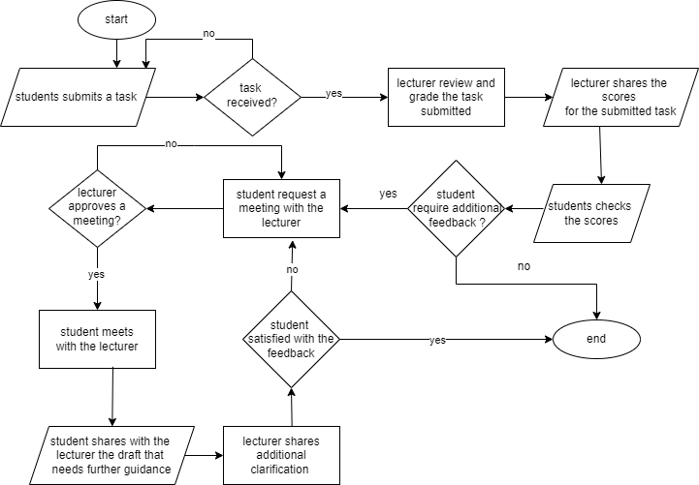

Figure 6: Flow chart for the current system

### **4.2.2 Use case diagram**

A use case diagram is a graphical depiction of the interaction among systems elements. In the current systems the use case diagram shows the interaction among the target group.

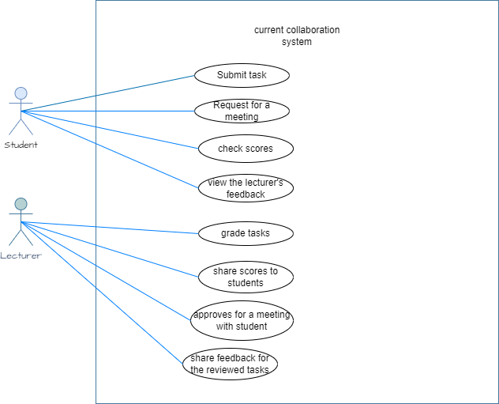

Figure 7: Use case diagram for the current system

### **4.2.3 ERD for the current system**

The ERD below visualizes the relationship between entities in the current system.

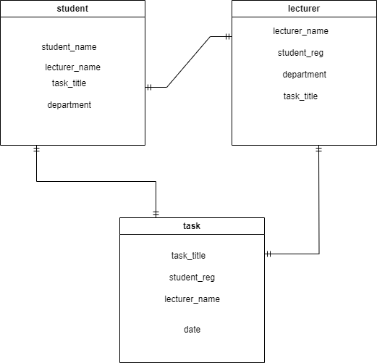

Figure 8: ERD for the current system

### **4.2.4 DFD for the current system**

This diagram below illustrates the relationships between IT students and lecturers in the current manual system it highlights how feedback and meeting requests are handled.

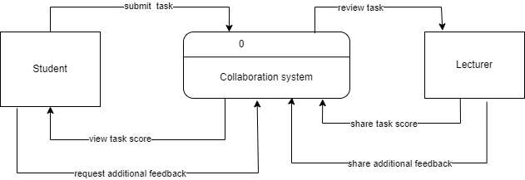

Figure 9: Level 0 context diagram for the current system

## **4.3 Strength of the current system**

* The current system enables students to achieve significant improvements in their tasks, provided they consistently engage with their lecturer for regular progress tracking and feedback.

## **4.4 Weakness of the current system**

The challenges of the current as depicted in the diagrams above includes;

* Inconsistencies in feedback tracking make it challenging for lecturers to pinpoint which deliverable require additional focus and attention.
* As a manual delivery process, task progress tacking heavily relies on frequent interactions to ensure effective outcomes.
* Time consuming and delays, scheduling involves back-and-forth communication via the email or WhatsApp systems leading to students and lecturers spend time coordinating schedules.

## **4.5 Findings from the analysis**

The major techniques that was used during the analysis process was Interviews and Observation.

### **4.5.1 Interviews**

Interviews were conducted with approximately 3 lecturers specializing in computing department and 10 IT students. The interview format included open-ended questions designed to explore the functionality of the current system and gather user opinions about the proposed solution. This approach provided valuable qualitative data that offered insights into the preferences and expectations of both lecturers and students.

### **4.5.2 Observation**

Observations were instrumental in the data collection process, providing a firsthand understanding of student workflows related to academic projects. The technique involved closely observing students engaged in various projects to identify typical and challenging processes they encounter. This included task submission, scheduling face-to-face meetings with lecturers, and tracking feedback on submitted work or meeting requests. The insights gained from these observations highlighted inefficiencies and areas for improvement within the current system, offering valuable guidance for developing a more streamlined solution.

Key findings from the data collection techniques analyzed above include:

Feedback tracking

* The delays in the meeting scheduling process result in poor deliverables from students due to miscommunication about lecturer availability for scheduled meetings.
* Inconsistent methods of feedback documentation which is done on email, hand written copies and sometimes WhatsApp leads to difficulties in tracking progress over time.
* Decentralized records keeping poses the challenge of storing and reviewing feedback, making it hard for student and lecturer to reference past recommendations.

Task submission

* Manual submissions via email or physical handovers leads to incidents of misplaced submissions and delays.
* Limited notifications and lack of alerts or confirmations lead to missed deadlines and incomplete submissions by students.
* Lecturers face challenges in monitoring submitted tasks and identifying pending submissions due to a lack of an automated tracking system.

## **4.6 Requirements of the proposed system**

### **4.6.1 User requirements**

1. Task management: the system should enable the lecturer/ mentor to assign tasks to students and set deadlines for completion.
2. Meeting scheduling: the system should allow scheduling and meeting rescheduling.
3. Feedback notification: the system should allow receiving of feedbacks for clarity purposes.
4. Resource management: the system should allow sharing and simultaneous updating of documents.
5. Customization: the system should allow the user to customize the interface and other features in the systems to their needs.

### **4.6.2 Functional requirements**

They describe what the system is expected to do or perform. They define the intended behavior of the system as it relates to the systems functionality. They include;

1. The system should provide automated meeting scheduling.
2. The system should provide a real-time feedback to enhance interaction activities.
3. The system should enable both students and lecturer to view task results.
4. The system should provide a report on the student project progress

### **4.6.3 Non-functional requirements**

Non-functional requirements impose specific constraints on the proposed system to ensure it operates as expected.

These address aspects include;

1. The system must be able to display on different device types and sizes of phones
2. Improve reliability for the users to access it at any time.
3. The system should be able to deny non-authorized users from accessing information through provision of administrative restrictions including passwords.

### **4.6.4 Business requirements**

To support the organization’s overall strategy and operation, the system will have the following business requirements:

1. Improved project efficiency and productivity: The system should streamline meeting scheduling and task management, enabling teams to work more efficiently and effectively.
2. Enhanced collaboration and communication: The system should facilitate collaboration and communication among team members in a centralized system, reducing miscommunication and improving task outcomes.
3. Improved student accountability and transparency: The system should provide real-time visibility into project progress and task status, enabling user to make informed decisions.
4. Regulatory compliance: The system should comply with relevant regulatory requirements, such as data privacy and security regulations to avoid legal risks.

## **4.7 Description of the proposed system**

The proposed system will be accessible exclusively to registered users, providing a secure and user-friendly environment. It aims to streamline the process of scheduling meetings with lecturers to reduce delays by automating appointment arrangements. Additionally, it will enhance feedback tracking with real-time notifications ensuring students can easily access timely updates from lecturers. This solution is designed to improve communication efficiency and support continuous project development for students and lecturers.

### **4.7.1 Flow chart diagram for the proposed system**

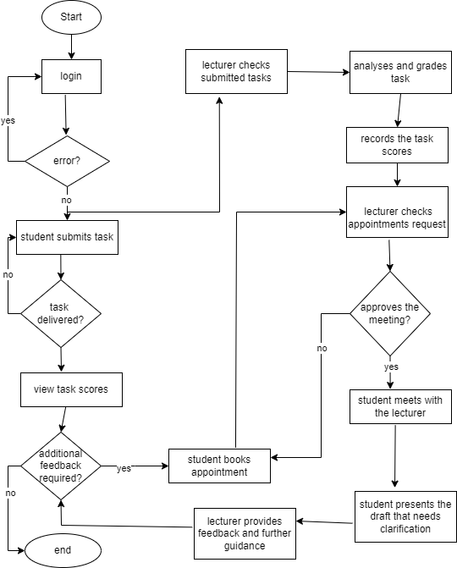

Figure 10: Flow chart for the proposed system

### **4.7.2 Use case diagram for the proposed system**

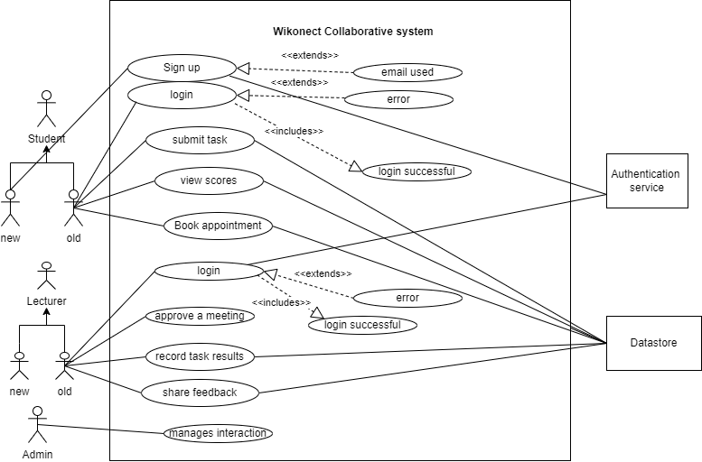

Figure 11: Use case for the proposed system

### **4.7.3 DFD for the proposed system**

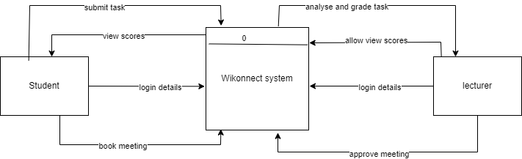

Figure 12: Level 0 Context diagram for the proposed system

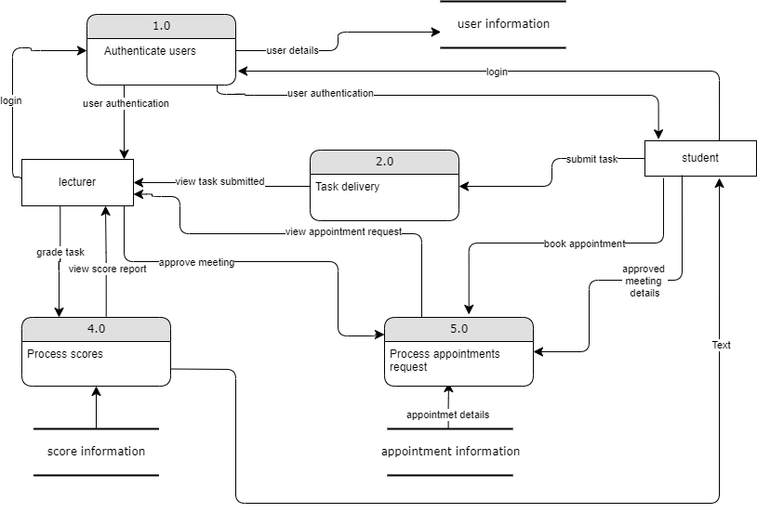

Figure 13: Level 1 context diagram for the proposed system

# **Appendix A: Interview**

**Interview Questions**

**For Lecturers:**

1. How would you describe your overall experience with the current collaboration management system for student and lecturer interaction?

**Response:** Most lecturers expressed frustration with the lack of a streamlined process for managing student task. Many mentioned issues with tracking progress and providing timely feedback as some students lack the discipline of reaching out to their lecturer frequently, this results to inconsistencies in tracking task progress even identifying the difficult areas to be addressed.

1. What challenges do you face in providing feedback to students within the current system?

**Response:** Common challenges include delayed feedback due to scheduling conflicts and difficulties in maintaining a centralized record of feedback. The existing system lack reminders which are essential in notifying about pending tasks

1. How do you track the progress of your students’ projects?

**Response:** Lecturers often rely on manual tracking through emails or physical meetings, leading to gaps in tracking and communication.

1. How effective do you find the communication process with students regarding meetings and project updates?

**Response:** Communication is generally effective, but scheduling meetings is often a challenge as students and lecturers struggle to align their schedules.

1. What improvements would you suggest for the current feedback tracking system?

**Response:** Suggestions included implementing a centralized feedback platform that would allow both students and lecturers to track progress and feedback in real-time.

1. How often do you interact with students about their project progress?

**Response:** Interactions typically occur once every week or can vary depending on the work schedule at a given period, though some lecturers would prefer more frequent check-ins which tends to consume a lot of time due to back-and- forth rescheduling with the current system.

1. How do you feel about the task submission process and its impact on project quality?

**Response:** The task submission process is seen as inefficient, with some students failing to meet deadlines due to the lack of automated reminders, sometimes handpicked assignments have a high potential of being misplaced.

### **For Students:**

1. How easy is it for you to submit tasks within the current system?

**Response:** Most students reported difficulties with the submission process, often relying on email or in-person handovers, leading to lost tasks or missed deadlines. In occasions where assignments is submitted via this fragmented systems, some students are recorded missing marks due to inconsistencies in tracking submitted tasks by the lecturer.

1. Do you feel that feedback on your work is timely and clear? Why or why not?

**Response:** Many students stated that feedback is often delayed, unclear or responded in a way that makes it difficult to understand and act upon.

1. How do you usually schedule meetings with your lecturer? Are there any challenges?

**Response:** Scheduling meetings is a major challenge, as students often struggle to find time slots that work for both themselves and their lecturers.

**Scheduling of meeting occurs when a student meet with the lecturer and agree when to hold a discussion regarding a given task or a student has to make a phone call to confirm the lecturer availability which is an unreliable process.**

1. What difficulties do you face in tracking the feedback on your submitted work or requests for meetings?

**Response:** There is no centralized platform for tracking feedback, students often forget or miss out on scheduled meetings due to lack of reminders. In other occasions students will visit their lecturer according to agreed date but he/ she might be unavailable.

1. How would you improve the current system to make task submission and feedback tracking more efficient?

**Response:** Students suggested implementing an automated task submission and feedback tracking system to enable students receive notification regarding pending tasks, received task and the feedback from the lecturers.

1. How do you stay informed about your deadlines and feedback?

**Response:** Many students stated that they rely on personal reminders or manual tracking methods like asking from classmates since the current system does not offer automated notifications.

1. What additional features would you find helpful for improving your project management process?

**Response:** Key suggestions included the integration of a scheduling feature, automatic notifications for deadlines and meetings and a centralized dashboard for feedback.